20.16: a) From Eq. (20.13), 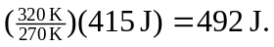b) The work per cycle is 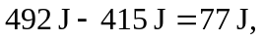 and 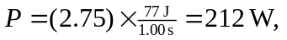keeping an extra figure.
c)

